**WASTEWATER GENERATION AND TREATMENT**

A project Submitted

in Partial Fulfilment of the Requirements

for the Degree of

Bachelor of Technology

in

BTech (CSE)

As part of the **“Probability and Statistics”**course

By:

 Rishita Ojha - 210187

Harshita Bansal - 210210

Aditi Singh - 210382

To:

 Dr. Ranjib Banerjee



SCHOOL OF ENGINEERING AND TECHNOLOGY

BML MUNJAL UNIVERSITY GURGAON

May 2022

**ACKNOWLEDGEMENT**

First and foremost, we are very much thankful to our Lecturer **Dr. Ranjib Banerjee** for his guidance, encouragement, help, and useful suggestions throughout the completion of the project. His untiring and painstaking efforts and individual help made it possible for our group to complete this work on time. We are glad that we got an opportunity to know more things about the concepts. We would like to appreciate ourselves for the cooperation, and team spirit we had.

We would also like to appreciate the technology which made our work simpler and easier. We would like to appreciate the web, resources, and our Textbook where we got sufficient information to complete our project.

**CONTENTS**

Abstract…………………………………………………4

Introduction…………………………………………….5

Materials and Methodology…………………………….6

Results ………………………………………………….10

Conclusion…………….………………………….……16

References………….………………………………….17

**ABSTRACT**

We have briefly described the wastewater generation and the treatment through all the states by our statistical analysis. An analysis of data has been carried out using various methods to determine the factors that promote the treatments in all the states. This includes hypothesis and studies of different types of wastewater generation also called sewage through all the states. We have taken the State-wise Sewage Generation data and have described all the factors that took place and then took out the treatment graph and the conclusion of the data.

**INTRODUCTION**

**Wastewater treatment**, also called **sewage treatment**, is the removal of impurities from wastewater, or sewage before it reaches [aquifers](https://www.britannica.com/science/aquifer) or natural bodies of water such as [rivers](https://www.britannica.com/science/river), [lakes](https://www.britannica.com/science/lake), [estuaries](https://www.britannica.com/science/estuary), and [oceans](https://www.britannica.com/science/ocean).

Discharge of untreated sewage in watercourses both surface and ground waters are the most important water-polluting source in India.

Out of about 38000 million liters per day of sewage-generated treatment, the capacity exists for only about 12000 million liters per day. Thus, there is a large gap between the generation and treatment of wastewater in India.

The objective of wastewater treatment is to reduce the pollutants to less than maximum permissible limits to prevent the threat to the environment and human health. To achieve this, wastewater is collected and treated in large plants before it is permitted to be released back into the environment.

**MATERIALS AND METHODOLOGY**

**Study Area-**This study is descriptive survey covering waste water treatment installed capacity and operational treatment capacity. The data used were supplied from ENVIS Centre on Hygiene, Sanitation, Sewage Treatment Systems and Technology.

**Statistical Analysis-**Data were analysed using statistical package. It shows the mean, variance, standard error; etc. With the bar graph and donut graph using R. P value below 0.05 was considered as statistically significant.

**Data Interpretation-**The following method were used to analyse the data.

* A confidence interval is the mean of your estimate plus and minus the variation in that estimate. This is the range of values you expect your estimate to fall between if you redo your test, within a certain level of confidence. Confidence, in statistics, is another way to describe probability.

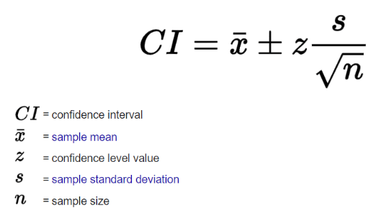

* Hypothesis Testing- Null and the alternative both hypothesis is stated about the accidents. Level of significance is specified as 5%. We compare the expected result to observed result. We took the data of proposed waste water treatment and operational waste water treatment. Null hypothesis is based on the dependence of operational treatment capacity on installed capacity.

**State-wise Sewage Generation and Treatment Capacity of Urban                 Centres-India**

|  |  |  |  |  |  |
| --- | --- | --- | --- | --- | --- |
| **States / UTs** | **Sewage Generation (in MLD)** | **Installed Capacity (inMLD)** | **Proposed Capacity (inMLD)** | **Total Treatment Capacity**  **(in MLD)including**  **planned/proposed** | **Operational Treatment Capacity**  **(inMLD)** |
| Andaman          &  Nicobar Islands | 23 | 0 | 0 | 0 | 0 |
| Andhra Pradesh | 2882 | 833 | 20 | 853 | 443 |
| Arunachal  Pradesh | 62 | 0 | 0 | 0 | 0 |
| Assam | 809 | 0 | 0 | 0 | 0 |
| Bihar | 2276 | 10 | 621 | 631 | 0 |
| Chandigarh | 188 | 293 | 0 | 293 | 271 |
| Chhattisgarh | 1203 | 73 | 0 | 73 | 73 |
| Dadra   &    Nagar  Haveli | 67 | 24 | 0 | 24 | 24 |
| Goa | 176 | 66 | 38 | 104 | 44 |
| Gujarat | 5013 | 3378 | 0 | 3378 | 3358 |
| Haryana | 1816 | 1880 | 0 | 1880 | 1880 |
| Himachal Pradesh | 116 | 136 | 19 | 155 | 99 |
| Jammu & Kashmir | 665 | 218 | 4 | 222 | 93 |
| Jharkhand | 1510 | 22 | 617 | 639 | 22 |
| Karnataka | 4458 | 2712 | 0 | 2712 | 1922 |
| Kerala | 4256 | 120 | 0 | 120 | 114 |
| Lakshadweep | 13 | 0 | 0 | 0 | 0 |
| Madhya Pradesh | 3646 | 1839 | 85 | 1924 | 684 |
| Maharashtra | 9107 | 6890 | 2929 | 9819 | 6366 |
| Manipur | 168 | 0 | 0 | 0 | 0 |
| Meghalaya | 112 | 0 | 0 | 0 | 0 |
| Mizoram | 103 | 10 | 0 | 10 | 0 |
| Nagaland | 135 | 0 | 0 | 0 | 0 |
| NCT of Delhi | 3330 | 2896 | 0 | 2896 | 2715 |
| Orissa | 1282 | 378 | 0 | 378 | 55 |
| Pondicherry | 161 | 56 | 3 | 59 | 56 |
| Punjab | 1889 | 1781 | 0 | 1781 | 1601 |
| Rajasthan | 3185 | 1086 | 109 | 1195 | 783 |
| Sikkim | 52 | 20 | 10 | 30 | 18 |
| Tamil Nadu | 6421 | 1492 | 0 | 1492 | 1492 |
| Telangana | 2660 | 901 | 0 | 901 | 842 |
| Tripura | 237 | 8 | 0 | 8 | 8 |
| Uttar Pradesh | 8263 | 3374 | 0 | 3374 | 3224 |
| Uttarakhand | 627 | 448 | 67 | 515 | 345 |
| West Bengal | 5457 | 897 | 305 | 1202 | 337 |
| **Total** | **72368** | **31841** | **4827** | **36668** | **26869** |

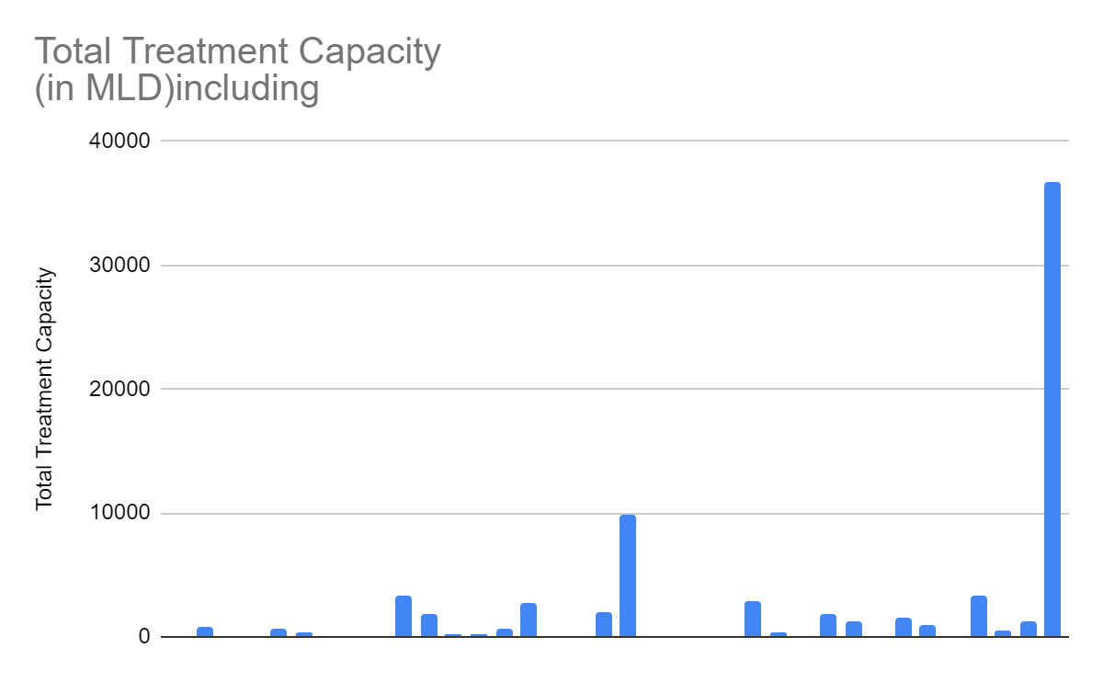

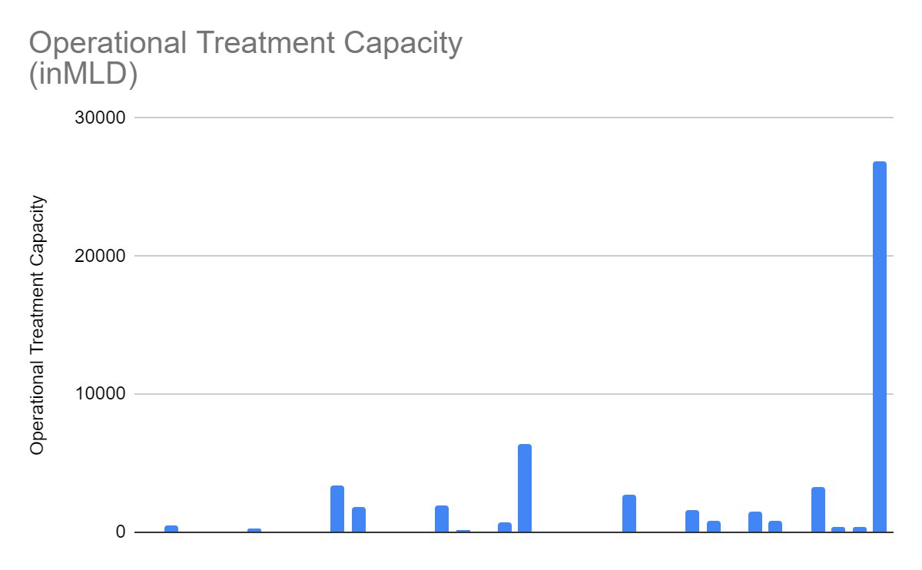

Page Break

**HYPOTHESIS TESTING:**

Critical region" redirects here. For the computer science notion of a "critical section", sometimes called a "critical region". statistical hypothesis test is a method of statistical inference used to decide whether the data at hand sufficiently support a particular hypothesis.

H0: The null hypothesis: It is a statement of no difference between sample means or proportions or no difference between a sample mean or proportion and a population mean or proportion. In other words, the difference equals 0.

Ha: The alternative hypothesis: It is a claim about the population that is contradictory to H0 and what we conclude when we reject H0.

In a hypothesis test, sample data is evaluated in order to arrive at a decision about some type of claim. If certain conditions about the sample are satisfied, then the claim can be evaluated for a population. In a hypothesis test, we:

1. Evaluate the null hypothesis, typically denoted with H0. The null is not rejected unless the hypothesis test shows otherwise. The null statement must always contain some form of equality (=, ≤ or ≥)

2. Always write the alternative hypothesis, typically denoted with Ha or H1, using less than, greater than, or not equals symbols, i.e., (≠, >, or <).

3. If we reject the null hypothesis, then we can assume there is enough evidence to support the alternative hypothesis.

4. Never state that a claim is proven true or false. Keep in mind the underlying fact that hypothesis testing is based on probability laws; therefore, we can talk only in terms of non-absolute certainties.

**R-CODE IMPLEMENTATION**

**OUTCOMES FOR THE DATA USED**

**For Sewage Distribution: -**

df <- data.frame(value = c(119007

                           ,41245-105096

                           ,556807-37719

                           ,36087-9036

                           30727

),

                 group = paste0("G", 1:5))

library(ggplot2)

library(dplyr)

# Hole size

hsize <- 3

df <- df %>%

  mutate(x = hsize)

ggplot(df, aes(x = hsize, y = value, fill = group)) +

  geom_col(color = "black") +

  geom_text(aes(label = value),

            position = position_stack(vjust = 0.5)) +

  coord_polar(theta = "y") +

  xlim(c(0.2, hsize + 0.5)) +

  scale_fill_discrete(labels=c

  ))

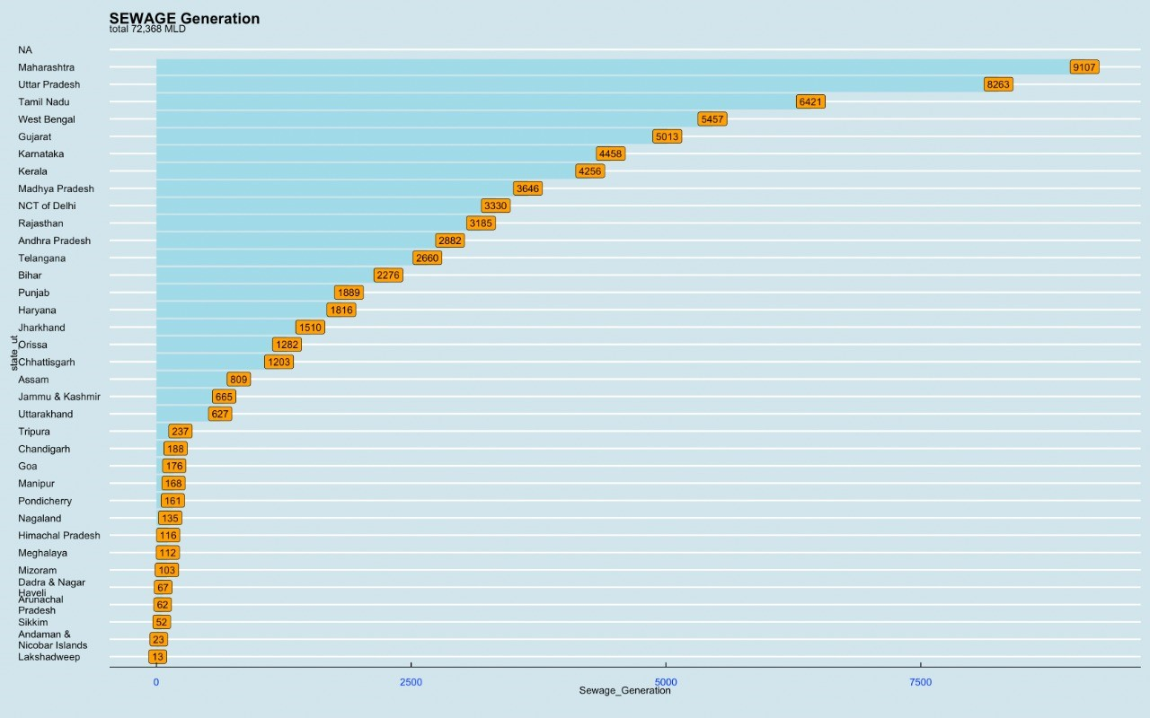

**For Installed Capacity:-**

library(prob)

library(distr)

library(distrEx)

library(ggplot2)

library(readr)

library(dplyr)

library(sfsmisc)

library(sf)

library(magrittr)

data <- read_csv("Documents/data9.csv")

View(data)

glimpse(data)

head(data)

library(ggthemes)

library(forcats)

data %>%

  select(one_of('state_ut','Installed_Capacity')) %>%

  arrange(desc(Installed_Capacity)) %>%

  head(36) %>%

  mutate(state_ut = fct_reorder(state_ut,Installed_Capacity)) %>%

  ggplot() + geom_col(aes(y = state_ut,x =Installed_Capacity), fill = 'pink') +

  geom_label(aes(y = state_ut,x =Installed_Capacity, label = Installed_Capacity), fill = 'white')+

  labs(title = 'INSTALLED CAPACITY IN DIFFERENT STATES/UT',

       subtitle = 'TOTAL IS 31,841',

       caption = '') +

  theme_hc(style = 'darkunica') +

  theme_economist() +

  theme(axis.text.x = element_text(color = 'blue'),

        axis.text.y = element_text(color = 'blue'))+

  xlim(0,7000)

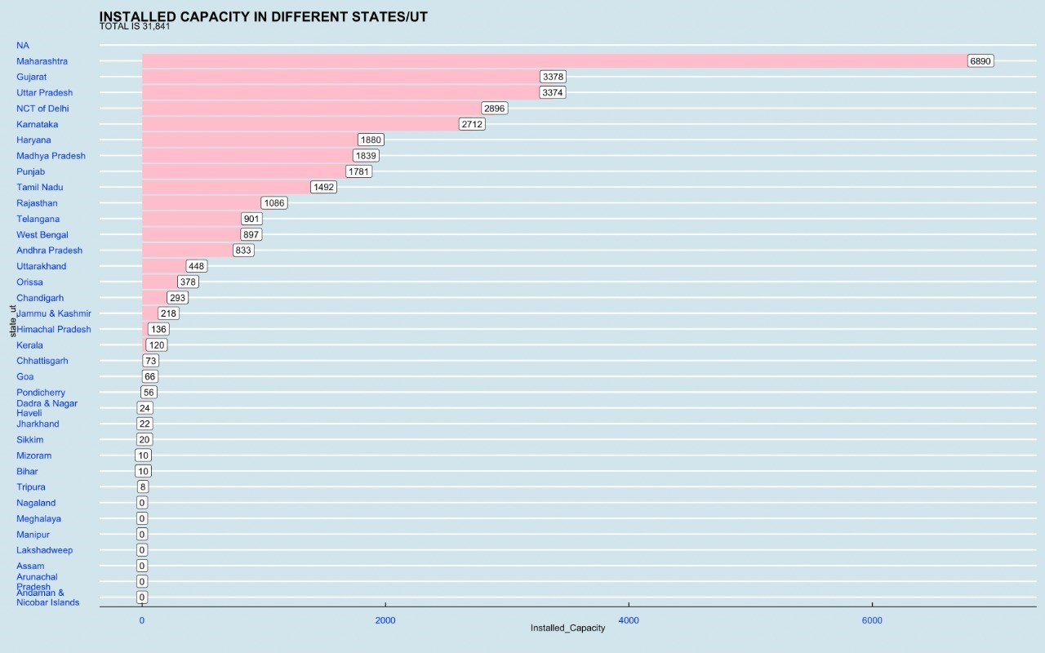

For Proposed Capacity:-

library(prob)

library(distr)

library(distrEx)

library(ggplot2)

library(readr)

library(dplyr)

library(sfsmisc)

library(sf)

library(magrittr)

data <- read_csv("Documents/data9.csv")

View(data)

glimpse(data)

head(data)

library(ggthemes)

library(forcats)

data %>%

  select(one_of('state_ut','Proposed_Capacity')) %>%

  arrange(desc(Proposed_Capacity)) %>%

  head(36) %>%

  mutate(state_ut = fct_reorder(state_ut,Proposed_Capacity)) %>%

  ggplot() + geom_col(aes(y = state_ut,x =Proposed_Capacity), fill = 'orange') +

  geom_label(aes(y = state_ut,x =Proposed_Capacity, label = Proposed_Capacity), fill = 'lightblue')+

  labs(title = 'PROPOSED CAPACITY IN DIFFERENT STATES/UT',

       subtitle = 'TOTAL IS 4,827',

       caption = '') +

  theme_hc(style = 'darkunica') +

  theme_economist() +

  theme(axis.text.x = element_text(color = 'black'),

        axis.text.y = element_text(color = 'black'))+

  xlim(0,3000)

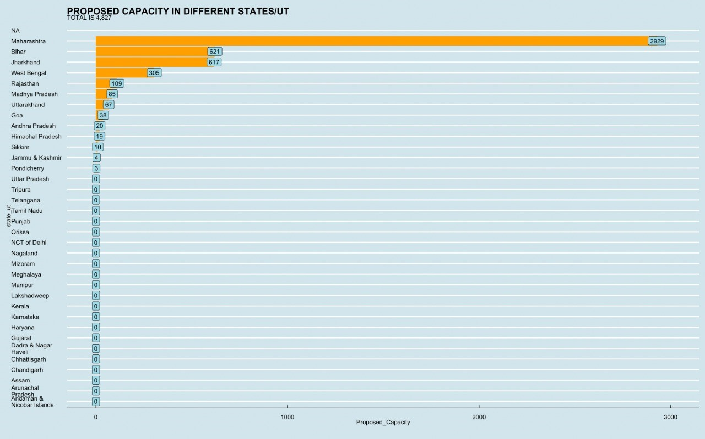

**Total Treatment Capacity – Including Planned/Proposed**

df <- data.frame(

      value = c( 0, 853, 0, 0, 631, 293, 73, 24, 104, 3378, 1880, 155, 222, 639, 2712, 120, 0, 1924, 9819, 0, 0, 10, 0, 2896, 378, 59,  1781, 1195, 30, 1492, 901, 8, 3374, 515, 1202),group = paste0("G", 1:35))

library(ggplot2)

library(dplyr)

# Hole size

hsize <- 3

df <- df %>%

      mutate(x = hsize)

ggplot(df, aes(x = hsize, y = value, fill = group)) +

      geom_col(color = "black") +

      geom_text(aes(label = value),

            position = position_stack(vjust = 0.5)

      ) +

      coord_polar(theta = "y") +

      xlim(c(0.2, hsize + 0.5)) +

      scale_fill_discrete(labels = c("Andaman & Nicobar Islands", "Andhra Pradesh", "Arunachal Pradesh", "Assam", "Bihar", "Chandigarh", "Chhattisgarh",  "Dadra & Nagar Haveli",  "Goa", "Gujarat", "Haryana", "Himachal Pradesh", "Jammu & Kashmir", "Jharkhand", "Karnataka", "Kerala", "Lakshadweep", "Madhya Pradesh", "Maharashtra", "Manipur", "Meghalaya", "Mizoram", "Nagaland", "NCT of Delhi", "Orissa", "Pondicherry", "Punjab", "Rajasthan", "Sikkim", "Tamil Nadu", "Telangana", "Tripura", "Uttar Pradesh", "Uttarakhand", "West Bengal" ))

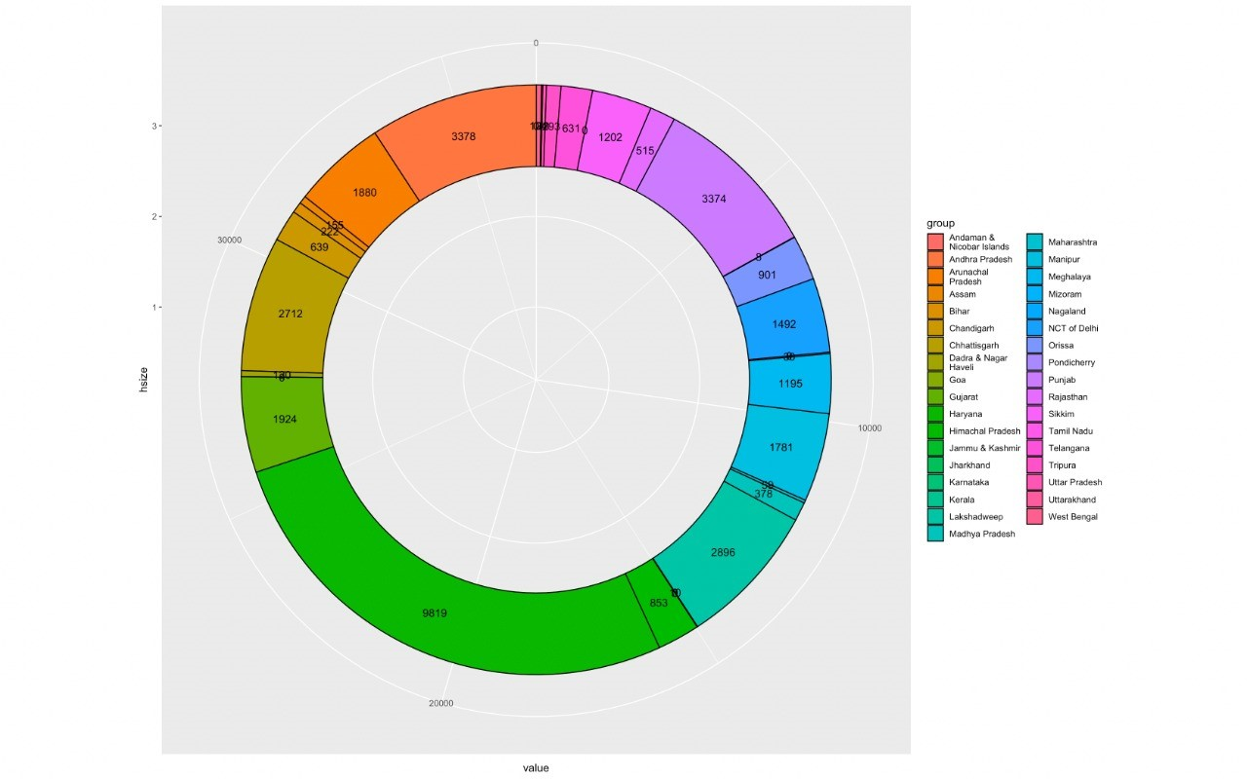

**Operational Treatment Capacity**

df <- data.frame(value = c(0 ,443 ,0 ,0 ,0 ,271 ,73 ,24 ,44 ,3358 ,1880 ,99 ,93 ,22 ,1922 ,114 ,0 ,684 ,6366 ,0 ,0 ,0 ,0 ,2715 ,55 ,56 ,1601 ,783 ,18 ,1492 ,842 ,8 ,3224 ,345 ,337 group = paste0("G", 1:35))

library(ggplot2)

library(dplyr)

# Hole size

hsize <- 3

df <- df %>%

  mutate(x = hsize)

ggplot(df, aes(x = hsize, y = value, fill = group)) +

  geom_col(color = "black") +

  geom_text(aes(label = value),

            position = position_stack(vjust = 0.5)) +

  coord_polar(theta = "y") +

  xlim(c(0.2, hsize + 0.5)) +

 scale_fill_discrete(labels = c("Andaman & Nicobar Islands", "Andhra Pradesh", "Arunachal Pradesh", "Assam", "Bihar", "Chandigarh", "Chhattisgarh",  "Dadra & Nagar Haveli",  "Goa", "Gujarat", "Haryana", "Himachal Pradesh", "Jammu & Kashmir", "Jharkhand", "Karnataka", "Kerala", "Lakshadweep", "Madhya Pradesh", "Maharashtra", "Manipur", "Meghalaya", "Mizoram", "Nagaland", "NCT of Delhi", "Orissa", "Pondicherry", "Punjab", "Rajasthan", "Sikkim", "Tamil Nadu", "Telangana", "Tripura", "Uttar Pradesh", "Uttarakhand", "West Bengal" ))

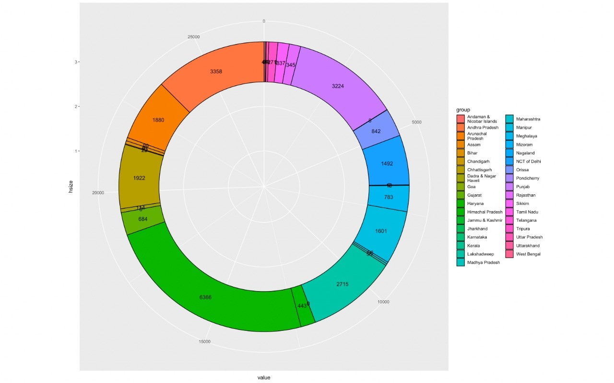

**HYPOTHESIS TESTING: -**

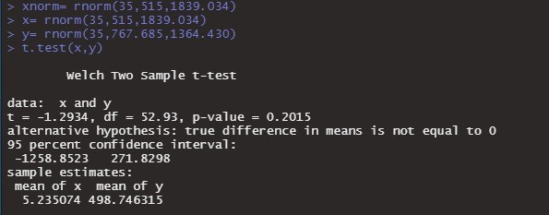

Code

alpha<-0.02

n<-6235,

xbar<-9.56

sigma<-3.11

zaby<-qnorm(1-alpha/2)

LCL<-xbar-(zaby2)*sigma/sqrt(n)

UCL<-xbar+(zaby2)*sigma/sqrt(n)

print(LCL)

print(UCL)

MET<-(zaby2)*sigma/sqrt

**CONCLUSION**

The successful implementation of wastewater reuse options in a water resources management program requires careful planning, economic and financial analyses, and the effective design, operation, and management of wastewater reclamation, storage, and distribution facilities. Technologies for wastewater reclamation and purification have developed to the point where it is technically feasible to produce water of almost any quality, and advances continue to be made. Current water reclamation strategies incorporate multiple measures to minimize the health and environmental risks associated with various reuse applications.

**REFERENCES**

https://www.azocleantech.com/article.aspx?ArticleID=37#:~:text=The%20objective%20of%20wastewater%20treatment,released%20back%20into%20the%20environment.

<http://www.sulabhenvis.nic.in/database/stst_wastewater_2090.aspx>

<https://www.britannica.com/technology/wastewater-treatment/Sewerage-systems>

<http://www.nzdl.org/cgi-bin/library?e=d-00000-00---off-0fnl2.2--00-0----0-10-0---0---0direct-10---4-------0-0l--11-ca-50---20-about---10-0-1-00-0--4----0-0-11-10-0utfZz-8-00&cl=CL1.5&d=HASH7ecfef951c65b8a6f0da56.9.9&gt=1>